**PYTHON WORKSHEET - 1**

1. (C) %
2. (B) 0
3. (C) 24
4. (A) 2
5. (D) 6
6. (C) the finally block will be executed no matter if the try block raises an error or not
7. (A) It is used to raise an exception
8. (C) In defining a generator
9. (A) _abc and (C) abc2
10. (A) yield and (B) raise

**STATISTICS WORKSHEET – 1**

1. (A) True
2. (A) Central Limit Theorem
3. (B) Modeling bounded count data
4. (D) All of the mentioned
5. (C) Poisson
6. (B) False
7. (B) Hypothesis
8. (A) 0
9. (C) Outliers cannot conform to the regression relationship

**Descriptive answers:**

1. 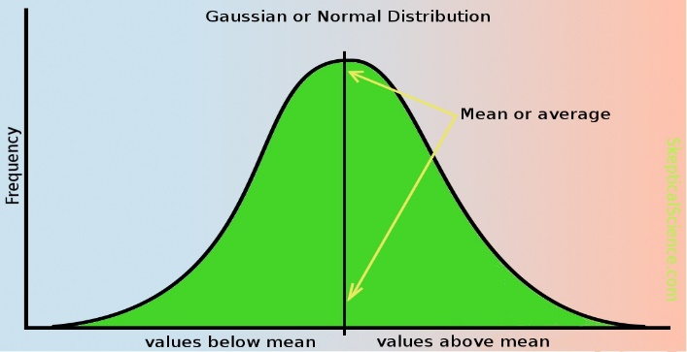A normal distribution has a bell-shaped curve which is a continuous probability distribution for independent random variables which is symmetric around its mean. It has a peak in the middle portion and the probability values decreases left and right.

It is useful to describe distribution of values for many natural phenomena such as height/salaries/IQ scores/grades of individuals from a group of people.

For a normal distribution, mean = median = mode

1. To handle missing data, two main methods can be used:
2. Imputation
3. Removing the data

Removing data may not be the best option because if we do not have enough data, removing some data related to the missing data will not result in reliable result. So, by imputation, we can develop a reasonable guess for the missing data. But first, we need to find out why the data is missing, so that we can make a good guess for the missing data.